健行科技大學 114 學年度第 2 學期
產學合作國際專班國際企業經營系系四_年甲班
新南向產學合作專班成果月報
填表月份： 4月
成果類別: ▇上課實景（教學狀況照片）
▇課堂成果（如實作課程作品等等）

姓名 | 吳秀英 | 課程名稱 | 商業簡報與溝通技巧
此課程結合理論與實際應用。學生們在聆聽單元理論之後，分組演練。此練習為設定目標族群推銷展品。
This course integrates theory with practical application. After learning the listening unit theories, students will work in groups to practice.
This activity involved identifying a target audience and promoting an exhibit to them.
照片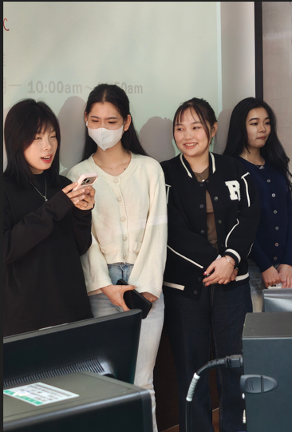1
每週課程依據實際教學進度與學生學習狀況調整內容，靈活規劃以達成教學目標與學習成效。
The weekly course content is adjusted based on the actual teaching progress and students’ learning conditions. It is flexibly planned to ensure the achievement of instructional objectives and learning outcomes.
照 2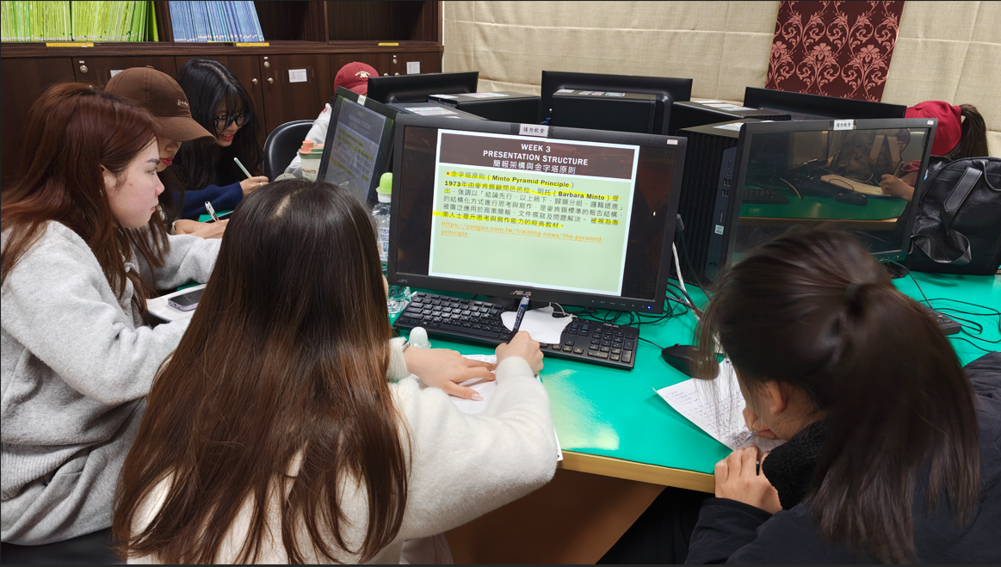 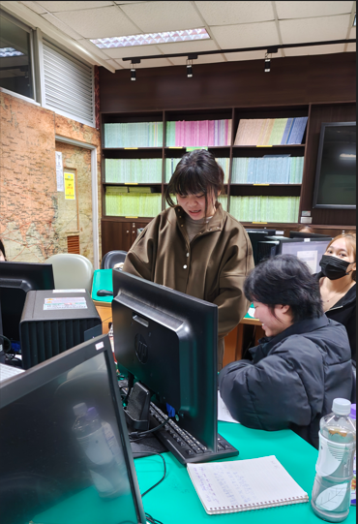
學生利用電腦觀看課程內容，作筆記，並進行實務練習。
In these photos, students used computers to view the course content, took notes, and engaged in practical exercises.
照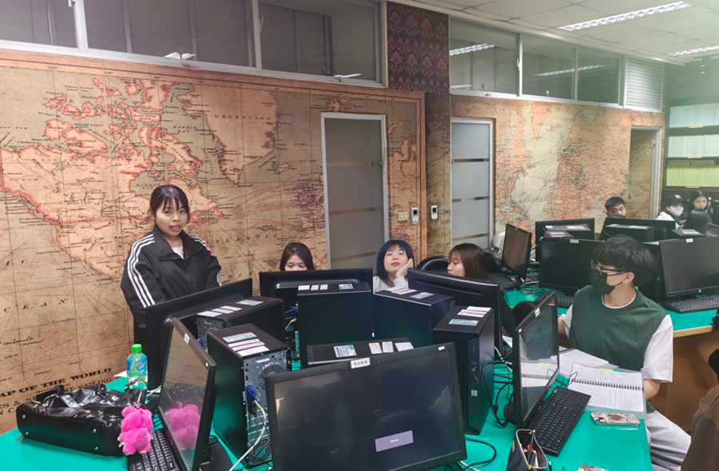片1
此週課程主題為口語與肢體表達，學生聆聽理論與觀賞相關短片之後，分組練習眼神接觸。
This week’s topic focused on verbal and nonverbal expression. After listening to the theory and watching related short videos, students practiced eye contact in groups.
照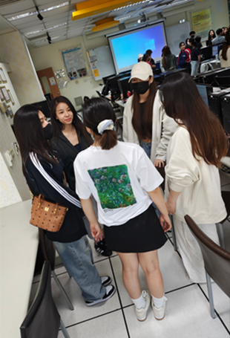 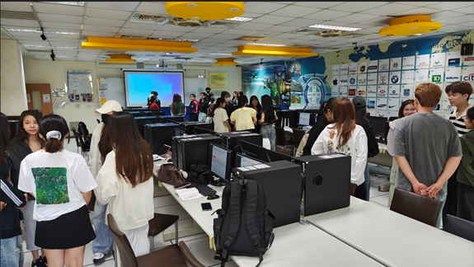
期中口試，學生一一輪流上台演說。練習課程中所提及的站穩再說，跟觀眾眼神接觸，身體語言，還有說話的音量與語調。
For the midterm oral exam, students took turns giving a presentation. They applied what had covered in the course, including standing firmly before speaking, maintaining eye contact with the audience, using effective body language, and controlling their volume and intonation.
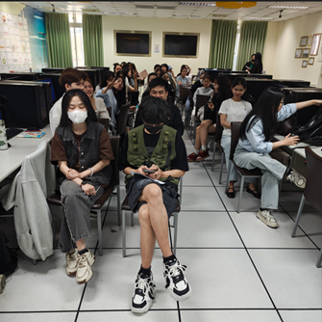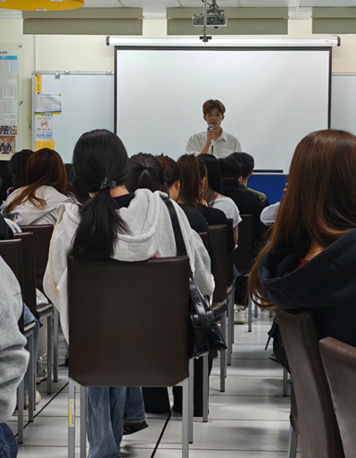
註: 最前排這位同學拿手機幫忙計時，每位同學兩分鐘。
Ps. The student in the front row used his phone to keep time; each student had two minutes.

